GREAT MAPLESTEAD PARISH COUNCIL
Parish Council Meeting held at the Village Hall on Wednesday 29th November 2017
Present Cllr.M.Elms (Vice-Chairman). Cllr.P.Maile. Cllr.J.Newton. Cllr.I.Johnson.Cllr.P.Haylock. Mrs.A.Crisp – Clerk. Members of the Public – 3.

MINUTES

- Apologies and reasons for absence Cllr.D.Turner – holiday. Cllr.S.Harris – caring duties.

- Minutes of previous meeting –The minutes of the Parish Council meeting held on the 25th October 2017, were accepted as a true and accurate account of proceedings of the meeting. Proposed by Cllr.Haylock, seconded Cllr.Johnson.

- Declarations of Interest None.

- County and District Matters – Dist. Cllr. J.O’Reilly-Cicconi advised that the Local Plan had been submitted to the Planning Inspectorate for assessment on the “soundness” of the plan. Council Tax – there remains a budgetary deficit and the council are proposing continued household increases in the coming years, parishioners and councillors were invited to express any concerns they may have direct to BDC. BDC Chairman’s Annual Civic Reception – in 2018 the theme will be “celebrating communities”. Nominations were invited for details of any parishioners who have contributed much to their local community, who may deserve recognition at the civic reception in March. Nominations required by Friday 8th December. Details to be placed on the Parish Council website to help promote.
Cllr.O’Reilly-Cicconi left the meeting at this time.

- Officers Reports & Information Exchange – No business decisions may be made.
Cllr.Maile - No report.
Cllr.Haylock – Confirmed agreement to help with refurbishment of the parish noticeboard in Lucking Street.
Cllr.Newton – No report.
Cllr.Johnson – Neighbourhood Watch – Seasonal personal and property security warnings, to secure windows and doors. Beware of oil tank thefts and handbag/wallet thefts.
Cllr.Harris – Written report – Appendix 1
Cllr.Elms – Highways – the damaged railings in Monks Lodge Road, on the corner beyond Chelmshoe Farm, have been repaired by Essex Highways. The village triangle adoption scheme is working well, and the triangle at the top of Church Street has had the litter bin varnished, and crocuses planted for the spring – thanks extended to Brian Chambers. Task Force – Litter on the verges and footpaths is an increasing problem and parishioners are encouraged to help pick up litter when out walking. An appeal for help will be made in the next edition of the Maplestead Magna Carta. Lucking Street Drainage- Some amendments have been made to ECC’s proposed plans, further information awaited.

- Public question time Members of the public were invited to ask questions.
Could the council provide further information on the Essex Highways notice in the recent edition of the Halstead Gazette, in which a number of road closures in and around Great Maplestead were cited? The Clerk confirmed the council had not received any recent road closure notifications, and it was agreed that there was a possibility that the published notice related to an historic notice issued late 2016/early 2017.

- Progress Updates – Clerk provided an update on action points from 25th October Meeting
Cllrs. Newton & Elms are yet to carry out maintenance work on village playing field car park surface.

8. Business Items
8.1 Village Notice Boards Repair – Cllr.Elms proposed that the council accept a quote of £45.00 to replace and repair the back board of the notice board in Lucking Street. Work to be undertaken by Martin Watson. Seconded Cllr.Johnson.

9. Financial Report
9.1 Current bank balances:-
Current account: |  | £55.44 | Reserve account: | £5405.92
9.2 Noting of sums received:-
NWB Interest Paid Oct 2017  BACS Essex CC – Footpaths SLA – Spring Cut  BACS Essex CC – Footpaths SLA – Autumn Cut | 6p  £140.00  £140.00
9.3 Ratification of payments made:
Cheque – Concept Signs Essex Ltd – Village Playing Field Permissions sign £60.00
Transfers
From Reserve Account to Current Account £1000.00
Payment(s) to be made requiring approval:
On-line banking – Shelley Signs Ltd – Village Information Board £1452.00
Proposed by Cllr.Haylock, seconded Cllr.Newton. Vote in favour Unanimous
Cheque – Information Commissioner – Data Protection License Renewal £35.00
Cheque – Trustees of Great Maplestead Village Hall Apr-Nov x 6 hall hires £78.00
Both cheque payments proposed by Cllr.Newton, seconded by Cllr.Haylock

10. Planning
10.1 Application Decisions
17/00314/TPO St Giles School, Church Street – Removal of all dead wood from 1 oak and reduce by approx. 1 metre of selected branches overhanging neighbouring property. Approved 19/10/17.
10.2 Applications Received
None

11. Correspondence – For notification
St Giles CofE School – Notification regarding burning of building waste at Highview development site, reported by school to BDC Environmental Health Officer. The Clerk noted a further letter had been received, following publication of the agenda, from C & K Contracts Ltd apologising for a fire from the clearance of hedging/shrubs on the boundary at April Cottage on 13th November.
Data Protection Bill- Latest update from NALC on GDPR and impact on parish councils, clarity on effect on small councils still required.
Parishioner Correspondence Regarding Salt Bin in Church Street – Communication received following publication of agenda, concerns raised regarding access to the salt bin in Church Street outside of the development known as Buttercups. Cllr.Elms has spoken to developers to ensure the bin can be accessed.
Parishioner Correspondence Regarding Skip Waste in Church Street- Communication received following publication of agenda. Reported waste spilling into the street from the skip outside the development at Buttercups. Problem caused by recent strong winds. Cllr.Elms has spoken with developer and the waste has now been removed

12. Content for E-newsletter
Litter, Village Information Board

13. Items for the Next Agenda
Precept
Annual Budget

14. Date of next meeting: 10th January 2018 at 7.30pm

Meeting Closed 8.10pm

Signed ………TRUE COPY………………..…. Dated 10th January 2018

APPENDIX 1 - Report from Councillor Harris
Communications:

- Website:

- Report:

- The Maplesteads’ Fuel Syndicate page (https://greatmaplesteadpc.co.uk/local-amenities/maplestead-fuel-syndicate/) has been updated to include the ordering and delivery dates for 2018.
- The Highways page (https://greatmaplesteadpc.co.uk/highways/) now includes the road sweeping dates for 2018 and a link to Live Traffic Information.
- Average monthly use of the website in the 11 months year-to-date:
  - 385 unique visitors (+30/m from last month)
  - 536 visits (up 60/m)
  - 6350 pages viewed/2 minutes per view (relatively unchanged)

- Action Plan:

- A separate ‘Community Information’ page to be added for general and utilities information plus the Community and Emergency Information leaflets.

--ooOoo--

- E-newsletter (Maplestead Magna Carta):

- Report:

- The 17th issue of the newsletter was e-mailed to subscribers on 13th November.
- A number of printed copies were placed in the Church for general perusal.

- Action Plan:

- It was previously agreed that publication of the next issue should be delayed until after the January PC meeting.
- Issue 18 is therefore scheduled for publication on w/c 29th January 2018 (tbc).
- Editorial content for this issue is currently suggested to include:
  - Community responsibility for litter control
  - VIB installation
  - A summary of any recent planning applications/decisions
  - Any interesting District/County news
  - Forthcoming events
  - Other subjects identified/requested during the separate agenda items in November/January

--ooOoo--

- Village Information Board:

- Report:

- Installation in the Playing Field car park was carried out by a dedicated Task Force team on 23rd November.

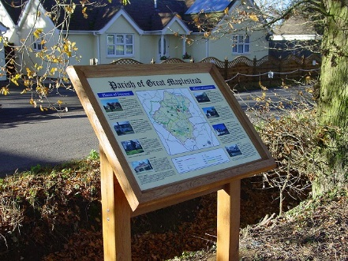 | 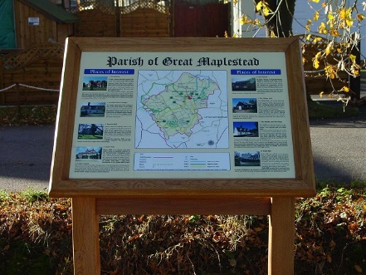 | 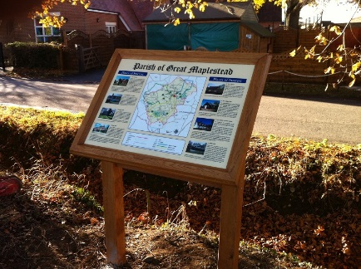

- Playing Field Sign

- Report:

- The new Terms & Conditions sign has been fixed in position close to the car park entrance of the Playing Field to ensure maximum visibility for users of this community amenity.

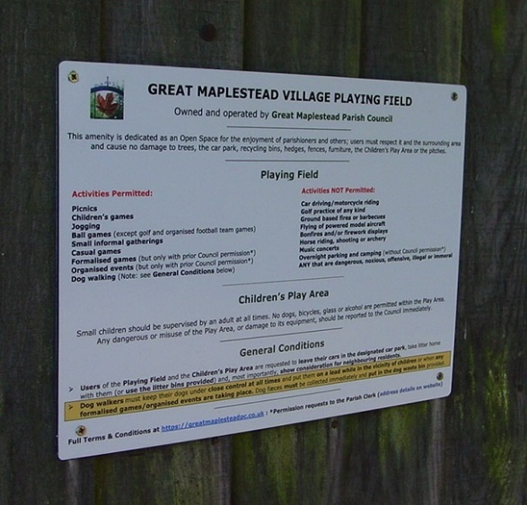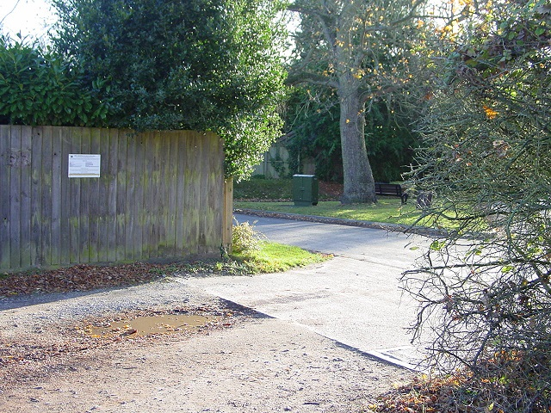

--ooOoo--

Footpaths:

- Report:

- Re-imbursement for the contractor cutting expenditure covered by the SLA grant has now been received from ECC.
- Confirmation of a PP3 grant for consumables & equipment maintenance has been received and will be paid on sight of ‘Paid’ receipts – deadline for submission March 2018.

- Action Plan:

- The current condition of the path network is on the Footpaths page of the website: https://greatmaplesteadpc.co.uk/footpaths/
- Interim assessment and maintenance will continue to be carried out on an ad hoc basis to monitor path conditions/rectify problems.
Appendix 1

