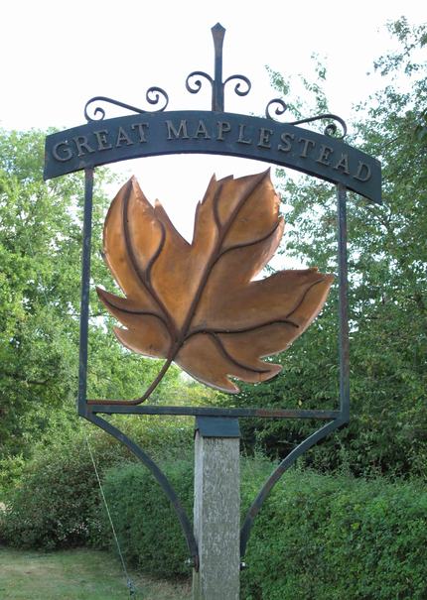


GREAT MAPLESTEAD PARISH COUNCIL
Members of the Great Maplestead Parish Council you are hereby summons to attend the ANNUAL PARISH COUNCIL MEETING of Gt. Maplestead Parish Council at the Village Hall, Gt. Maplestead on Wednesday 20th May 2015 at 7.30pm for the purpose of transacting the following business:

AGENDA

- Election of Chairman

- Election of Officers & Officer Responsibilities
  - Declarations of Office & agreed Councillor responsibilities
  - Approval required that Mr Peter Haylock may sign his Declaration of Office upon his return and prior to the next meeting of the Parish Council.

- Policies & Standing Orders – Amendments and adoption of policies and Standing Orders for 2015/16.
- Standing Orders
i). New Standing Order to be added - Delegation of power to Clerk for approval of requests to use Village Playing Field subject to pre-approved criteria (to be determined)
- Financial Regulations
- Complaints Procedure
- Publications Policy
- Grant Awarding Policy

- Meeting Dates for 2015/16 – Review of meeting dates for forthcoming business year

- Minutes of previous meeting – Councillors are asked to agree the minutes of the Parish Council meeting of the 11th March 2015 as a true and accurate account of proceedings of the meetings.

- Declarations of Interest (existence and nature) with regard to items on the agenda.
Members of the Council are advised to declare the existence and nature of any ‘Disclosable Pecuniary’, ‘Other Pecuniary’ or ‘Non-Pecuniary’ interests relating to items on the agenda.

- County and District Matters – Updates and notifications to be received.

- Public question time with respect to items on the agenda and other matters of mutual interest. Note: When the Council starts to discuss any item on the agenda where a member has an interest, the member with that interest must have regard to the Code of Conduct and make the necessary disclosure and leave the meeting where appropriate. The maximum time allowed for public question time is 10 minutes or at the Chairman’s discretion. At the close of this item members of the public will no longer be able to address the Council except at the invitation of the Chairman; members with Disclosable or Other Pecuniary interests will not be allowed to speak or address the Council on those interests unless a dispensation has been approved.

- Progress Updates & Legislation Advice –
  - Clerk to report on matters from the last meeting.
    - Smaller Authorities (Transparency Requirements) Regulations 2015 – Changes to be implemented
from 1st July 2015.

10. Business Items
10.1.1 Requests to use Village Playing Field –
Request from St Giles’ School & Friends of St Giles’ to use village playing field on 10th July 2015 for parking.
10.1.2 Request from Mr Bob Chaplin for use of village field for classic car show during Great Maplestead Flower Festival.
10.1.3 Annual request from St Giles CofE School for continued use of the village playing field.
10.2 Annual Street Cleansing Agreement – Contract and agreement with BDC to be approved and signed.
10.3 Purchase of 2 Replacement Spring Rockers for Children’s Play Area – S106 monies available to cover cost and already pre-approved by Braintree District Council.
10.4 Storage Container for Village Playing Field – Next steps to be agreed.
10.5 ECC Statement of Community Involvement Update 2015 – Consultation – Response to be determined.

11. Financial Report
11.1 Bank Reconciliation
11.2 Noting of payments received
11.3 Ratification of payments made & payments requiring approval
11.4 Other Financial Matters - Annual Insurance Renewal & Annual Audit

12. Planning
12.1 Application Decisions
12.1.1 15/00020/FUL Lucking Farm, Lucking Street. Description changed to better describe nature of application “to remove time restrictions for the collection of birds from the site.” Granted 20/3/2015
12.1.2 15/00149/FUL The Coach House, The Old Vicarage, Church Street. Proposed refurbishment and alterations.Granted 9/4/15
12.1.3 15/00140/FUL Barrington House, Dynes Hall Road. Erection of porch to the front of the property.Granted 25/3/15
12.1.4 15/00011/FUL Playing Field, Lucking St/Monks Lodge Road. Siting of container to be used as secure on site storage & servicing of parish council equipment for maintaining village field. Granted 10.4.15
12.2 Applications Received
None

13. Correspondence – For notification
None

14. Items for the Next Agenda
Please note that no decisions can lawfully be made under this item, LGA 1972 section 12 10(2)(b) states that business must be specified; therefore the Council cannot lawfully raise matters for decision.

15. Date of next meeting: 8th July 2015 @ 7.30pm


Ann Crisp – Clerk acrisppc@btinternet.com
Tel: 01787- 460216

