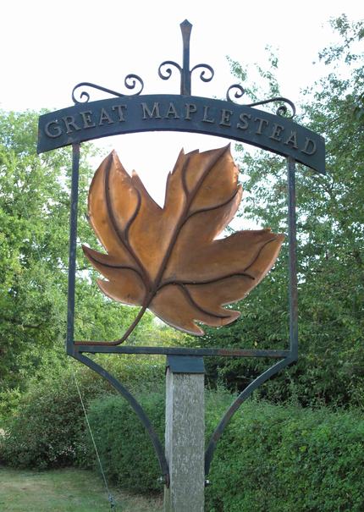
GREAT MAPLESTEAD PARISH COUNCIL

Members of the Great Maplestead Parish Council you are hereby summons to attend the ANNUAL PARISH COUNCIL MEETING of Gt. Maplestead Parish Council at the Village Hall,
Gt. Maplestead on Wednesday 21st May 2014 at 7.30pm for the purpose of transacting the following business:

AGENDA

- Apologies and reasons for absence

- Election of Chairman

- Election of Officers & Officer Responsibilities

- Policies & Standing Orders – Amendments and adoption of policies and Standing Orders for 2014/15.
- Financial Regulations
- Complaints Procedure
- Personnel - Grievance Policy

- Meeting Dates for 2014/15 – 2014 16th July, 27th August, 15th October, 10th December; 2015 21st January, 11th March.

- Minutes of previous meeting – Councillors are asked to agree the minutes of the Parish Council meeting of the 12th March 2014 as a true and accurate account of proceedings of the meetings.

- Declarations of Interest (existence and nature) with regard to items on the agenda.
Members of the Council are advised to declare the existence and nature of any ‘Disclosable Pecuniary’, ‘Other Pecuniary’ or ‘Non-Pecuniary’ interests relating to items on the agenda.

- County and District Matters – Updates and notifications to be received.

- Public question time with respect to items on the agenda and other matters of mutual interest. Note: When the Council starts to discuss any item on the agenda where a member has an interest, the member with that interest must have regard to the Code of Conduct and make the necessary disclosure and leave the meeting where appropriate. The maximum time allowed for public question time is 10 minutes or at the Chairman’s discretion. At the close of this item members of the public will no longer be able to address the Council except at the invitation of the Chairman; members with Disclosable or Other Pecuniary interests will not be allowed to speak or address the Council on those interests unless a dispensation has been approved.

- Progress Updates –
  - Clerk to report on matters from the last meeting.
  - Broadband Update – Progress on County Broadband proposition sent to St Giles PCC
  - ECC Highways 7.5t Weight Limit Restrictions in Castle Hedingham – Update on proposals

11. Business Items
11.1 ECC CIF Grant – Decision required on proposed size, purchase and location for new storage container on the village playing field. Approval required for project spend on purchase of container and associated works.
11.2 Dog Waste – Proposal for additional dog waste bins and to address issues regarding proper disposal of waste.
11.3 Verge Cutting – New provider to be approved.
11.4 Footpaths – Proposal to survey all parish footpaths and create a repair schedule
11.5 Annual Street Cleansing Agreement – Approval of annual agreement
11.6 Change to Street Name Plate at Purls Hill Lane – Request received from The Secretary of Molly’s Wood, Sible Hedingham to alter road sign to read “leading to Hulls Mill”

12. Financial Report
12.1 Bank Reconciliation
12.2 Noting of payments received
12.3 Ratification of payments made & payments requiring approval
12.4 Other Financial Matters - Annual Insurance Renewal & Annual Audit

13. Planning
13.1 Application Decisions
14/00247/FUL & 14/00248/LBC Hulls Mill House Hulls Mill Lane. Proposed lengthening & heightening of existing listed brick wall. Granted

13.2 Applications Received
14/00104/TPO St Giles Church, Church Street. Application to carry out works on trees affected by a TPO
14/00605/FUL Kilowen Farm, Dynes Hall Rd. Erection of a conservatory
14/00423/FUL Livery Stable at New Barn Farm, Alderford Street. Part change of use within existing structure from stable to joinery workshop

14. Correspondence – For notification
14.1 Recycling Centres for Household Waste - Notification of current ECC review
14.2 Summer Activity Days- Invitation to attend BDC information event
14.3 BDC Site Allocations and Development Management Plan – Latest update from BDC
14.4 Minutes from St Giles School Governors meeting - Addressing school parking issues

15. Officers Reports

16. Items for the Next Agenda
Please note that no decisions can lawfully be made under this item, LGA 1972 section 12 10(2)(b) states that business must be specified; therefore the Council cannot lawfully raise matters for decision.

17. Date of next meeting: 16th July 2014 at 7.30pm


Ann Crisp – Clerk acrisppc@btinternet.com
Tel: 01787- 460216

