GREAT MAPLESTEAD PARISH COUNCIL
Parish Council Meeting held at the Village Hall on Wednesday 10th January 2018
Present Cllr.D.Turner (Chairman). Cllr.P.Maile. Cllr.J.Newton. Cllr.S.Harris. Cllr.I.Johnson.Cllr.P.Haylock. Mrs.A.Crisp – Clerk. Members of the Public – 3.

MINUTES

- Apologies and reasons for absence–Cllr.M.Elms – illness.

- Minutes of previous meeting –The minutes of the Parish Council meeting held on the 29th November 2017, were accepted as a true and accurate account of proceedings of the meeting. Proposed by Cllr.Haylock, seconded Cllr.Johnson.

- Declarations of Interest Cllr. J Newton declared a Non-Pecuniary Interest as owner of neighbouring land to Agenda items 10.2 Planning Applications 17/02148/LBC St Giles Cottage, Lucking Street & 17/02226/FUL Monks Haven, Gestingthorpe Road,.

- County and District Matters – Dist. Cllr. J.O’Reilly-Cicconi advised that the districts budget will be approved by BDC in 2 weeks time. He is unsure of the District Councillors Grant scheme will be continued. Cty.Cllr Finch extended his apologies as unable to attend the meeting.
Cllr.O’Reilly-Cicconi left the meeting at this time.

- Officers Reports & Information Exchange – No business decisions may be made.
Cllr.Turner - No report.
Cllr.Johnson – Neighbourhood Watch – Reports of oil tank thefts and handbag/wallet thefts continue. An attempted child snatch has also been reported in Halstead in recent days.
Cllr,Maile – Bulbs have been purchased, with the help of the Maplestead Flower Club, to be planted in front of the fencing around the children’s play area on the village playing field. A possible rare bird nesting site has been identified within the parish and reported to the RSPB & Essex Recorder.
Cllr.Haylock – To be covered under Agenda item 10 Planning
Cllr.Newton – Drainage on the village playing field needs to be re-assessed. The car park surface, still requires attention to ensure it is level. Repairs were hampered by the snow fall in early December.
Cllr.Harris – Written report – Appendix 1

- Public question time Members of the public were invited to ask questions.
Concern has been raised by parishioners regarding ditches at the top of Lucking Street and Toldis Hall Road (near to Mill Lane) as they had both silted up? The Clerk advised she would liaise with Cllr.Elms & Essex Highways..

- Progress Updates – Clerk provided an update on action points from 29th November Meeting

8. Business Items
Budget 2018/19 – The Clerk pre-circulated a summary of the council’s budget forecast for the forthcoming year. The council’s reserves have seen a further small increase in the past year, attributed to further cost savings and use of local grants and S106 money. Precept remains the main source of income and 2018 sees the final payment of the Local Support Grant, placing further pressure on parish funds.
Precept 2018/19 – Three proposals were considered by the council:-
Option 1 – A total Precept increase of £200, equivalent to an increase of £1.25 per Band D household to £28.78.
Option 2 – A total Precept increase of £322, equivalent to an increase of £2.00 per Band D household to £29.53.
Option 3 – A total Precept increase of £395, equivalent to an increase of £2.45 per Band D household to £29.98.

Only Option 3 ensures expenditure is covered, (by £2.10).

The tax base used to calculate 2018/19 Band D rate for Great Maplestead is 163.55 (as advised by BDC).

Cllr.Haylock proposed the council adopt the calculations of Option 3 and agree a Precept of £4903.00 for 2018/19. Seconded by Cllr.Harris. Vote in favour – Unanimous.

9. Financial Report
9.1 Current bank balances:-
Current account: |  | £7.23 | Reserve account: | £3217.40
9.2 Noting of sums received:-
NWB Interest Paid Nov - Dec 2017  BACS HMR&C VAT Reimbursement | 38p  £461.10
9.3 Ratification of payments made:-
SO Salary Qtrly Payment to Clerk, Mrs A Crisp Sep-Dec £1133.21
Transfers
From Reserve Account to Current Account £1550.00
From Reserve Account to Current Account £1100.00
Payment(s) to be made requiring approval:-
None
Planning
10.1 Application Decisions
None
10.2 Applications Received
17/02148/LBC St Giles Cottage, Lucking Street. Removal of rear lean-to part glazed, part corrugated cement based sheet roof covering and provision of natural grey slate and two conservation roof lights, red clay terracotta chimney pot and cowl and removal of plaster beneath existing opening. Cllr.Haylock advised the proposal appeared “straight forward” and would be governed by Listed Buildings.
17/02226/FUL Monks Haven, Gestingthorpe Road. Erection of single storey rear extension
Cllr.Haylock advised that the proposed extension did not appear to affect other properties.
Cllr.Haylock proposed that the council should respond to both applications “No comments received or objections raised.” Seconded by Cllr.Harris.

11. Correspondence – For notification
Stansted Airport Correspondence – New flights to Dubai, to be operated by Emirates, will commence operation in June 2018.
Parishioner Correspondence – Letter received copying communication between parishioner and St Giles school regarding fallen branches. Further copy communication received from St Giles school. Matter to be resolved between affected parties.

12. Content for E-newsletter
Community responsibility for the local environment (litter/signs/triangles/play area planting); Village Information Board; Roadside furniture repair; Budget/Precept 2018/19; Website update; Regular Planning and Forthcoming Events sections

13. Items for the Next Agenda
Explore Parishioner Adoption of Village Furniture

14. Date of next meeting: 28th March 2018 at 7.30pm

Meeting Closed 8.09pm

Signed …TRUE COPY………..…. Dated 28th March 2018

APPENDIX 1 - Report from Councillor Harris
Communications:

- Website:

- Report:

- Last year EssexInfo (our website provider) recommended that we adopt one of their new ‘themes’ (the way the website looks) in order to improve the way our website worked on mobiles and tablet devices. They also advised that our existing theme would eventually be removed from their system.
- In December our site was therefore converted to the better-looking of these recommended ‘themes’, giving it a more modern, less cluttered look. At the same time some of the content was overhauled and rationalised to make the site simpler and more logical to navigate.
- As part of this overhaul:
  - a How to Get in Touch page was added: https://greatmaplesteadpc.co.uk/contact-the-council/
  - a downloadable version of the Community Information leaflet was linked to the Village Life page: https://greatmaplesteadpc.co.uk/parish-information/
  - links to the Emergency Information leaflet and proposed evacuation routes map were also added to the Useful Emergency Information page: https://greatmaplesteadpc.co.uk/general-information/useful-emergency-information/
  - a link was also established on the Events page to the Knights Hospitallers website so that visitors can now look up Church service dates and times.
- Other changes have included:
  - getting our website information corrected on Braintree DC’s Parish and Town Councils website page: http://braintree.cmis.uk.com/braintree/ParishandTownCouncils/tabid/130/FolderID/31/Great-Maplestead-Parish-Council.aspx
  - editing Great Maplestead’s Wikipedia page so that it now displays a link to our website: https://en.wikipedia.org/wiki/Great_Maplestead
- Average monthly use of the website during 2017 was:
  - 415 unique visitors
  - 577 visits
  - 6526 pages viewed/just under 3 minutes per view

- Action Plan:

- A request has been sent to Visit Essex asking it to amend its website to display our correct, current website details. This will be followed up regularly until it has been implemented.

--ooOoo--

- E-newsletter (Maplestead Magna Carta):

- Action Plan:

- Issue 18 is scheduled for publication on w/c 29th January 2018 (tbc).
- Editorial content for this issue is currently suggested to include:
  - Community responsibility for litter control
  - VIB installation
  - A summary of any recent planning applications/decisions
  - Any interesting District/County news
  - Forthcoming events
  - Other subjects identified/requested during the separate agenda items in January

--ooOoo--
Footpaths:

- Report:

- Confirmation of a PP3 grant for consumables & equipment maintenance has been received and will be paid on sight of receipts – deadline for submission March.
- The current condition of the path network is as below – and is also shown on the Footpaths page of the website: https://greatmaplesteadpc.co.uk/footpaths/

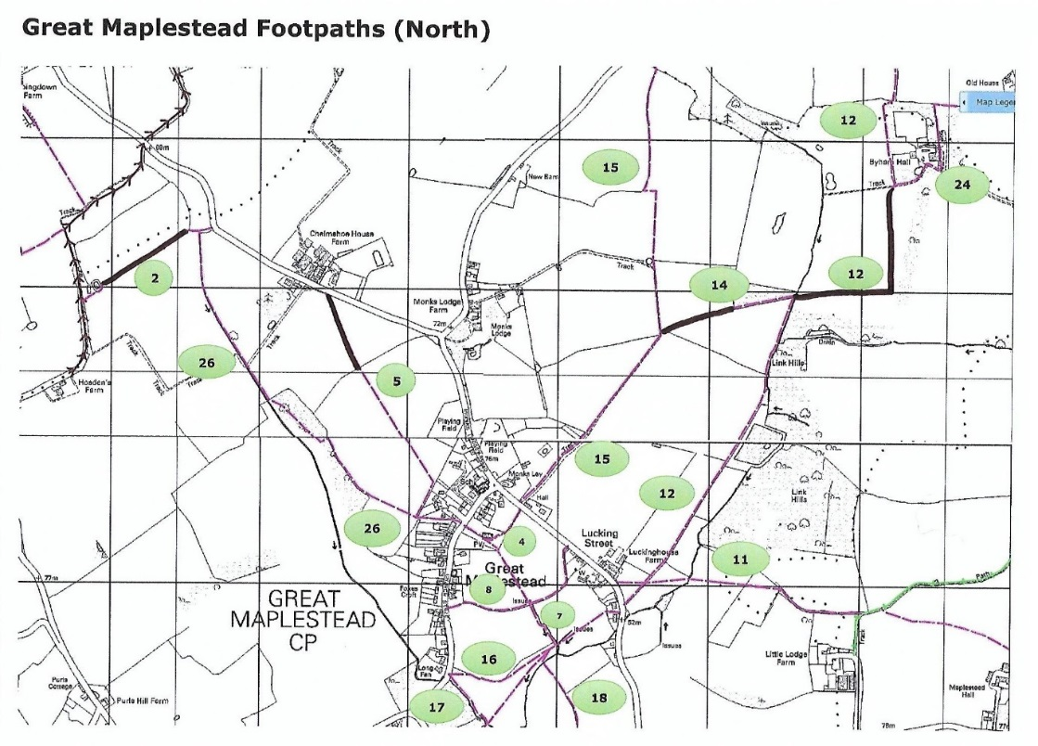
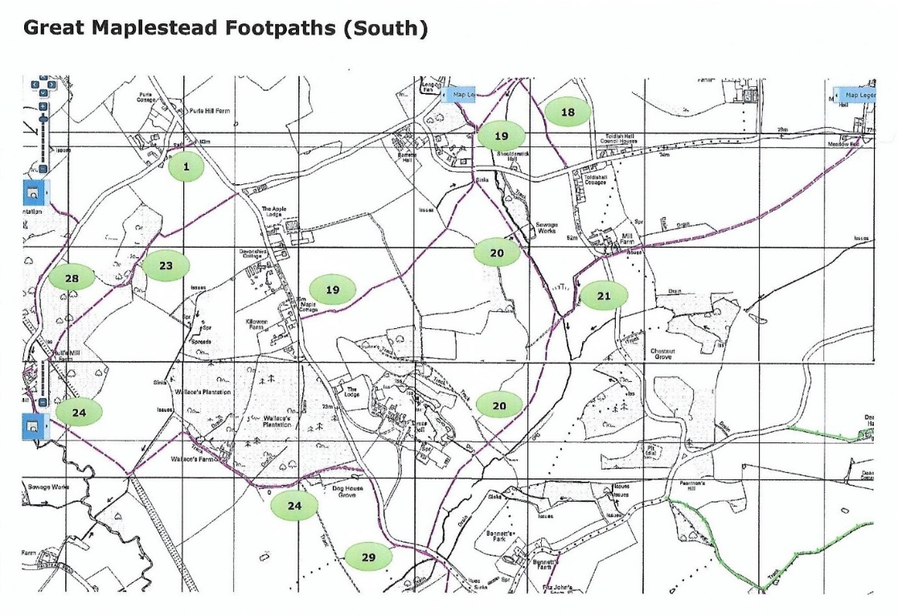
Pink Reasonable condition – clearance undertaken end September/October
Brown Sections presently affected by ploughing/sowing
Notes: FP 16 W of FP 7 – indistinct, but FP17/19 detour available

- Action Plan:

- Interim assessment and maintenance will continue to be carried out on an ad hoc basis to monitor path conditions/rectify problems.

