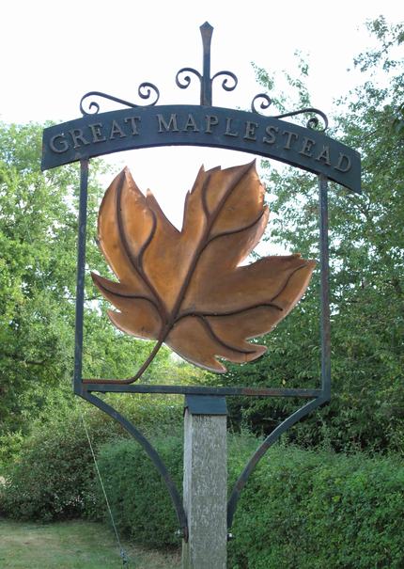


GREAT MAPLESTEAD PARISH COUNCIL

Members of the Great Maplestead Parish Council you are hereby summons to attend an EXTRA-ORDINARY PARISH COUNCIL MEETING of Gt. Maplestead Parish Council at the Village Hall, Gt. Maplestead on Monday 25th April 2016 at 6.30pm for the purpose of transacting the following business:

AGENDA

- Apologies and reasons for absence

- Declarations of Interest (existence and nature) with regard to items on the agenda.
Members of the Council are advised to declare the existence and nature of any ‘Disclosable Pecuniary’, ‘Other Pecuniary’ or ‘Non-Pecuniary’ interests relating to items on the agenda.

- Public question time with respect to items on the agenda and other matters of mutual interest. Note: When the Council starts to discuss any item on the agenda where a member has an interest, the member with that interest must have regard to the Code of Conduct and make the necessary disclosure and leave the meeting where appropriate. The maximum time allowed for public question time is 10 minutes or at the Chairman’s discretion. At the close of this item members of the public will no longer be able to address the Council except at the invitation of the Chairman; members with Disclosable or Other Pecuniary interests will not be allowed to speak or address the Council on those interests unless a dispensation has been approved.

4. Business Items
4.1. Braintree District Council Local Plan – A review of further amendments to the development boundary at Highview (Treeways), previously excluded from BDC notifications and response to BDC Local Plan Sub Committee.

5. Items for the Next Agenda
Please note that no decisions can lawfully be made under this item, LGA 1972 section 12 10(2)(b) states that business must be specified; therefore the Council cannot lawfully raise matters for decision.

6. Date of next meeting: 11th May 2016 at 7.30pm


Ann Crisp – Clerk anncrisp@greatmaplesteadpc.co.uk Tel: 01787- 460216

