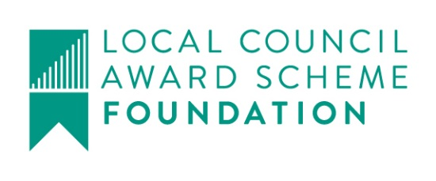

Great Maplestead Parish Council

Members of the Great Maplestead Parish Council you are hereby summonsed to attend a PARISH COUNCIL MEETING of Great Maplestead Parish Council at the Village Hall, Great Maplestead on Wednesday 29th November 2017 at 7.30pm for the purpose of transacting the following business:
AGENDA

- Apologies and reasons for absence

- Minutes of previous meeting – Councillors are asked to agree the minutes of the Parish Council meeting held on the 25th October 2017 as a true and accurate account of proceedings of the meeting.

- Declarations of Interest (existence and nature) with regard to items on the agenda. Members of the Council are advised to declare the existence and nature of any ‘Disclosable Pecuniary’, ‘Other Pecuniary’ or ‘Non-Pecuniary’ interests relating to items on the agenda.

- County and District Matters – Updates and notifications to be received.

- Officers Reports & Information Exchange – No business decisions may be made.

- Public question time with respect to items on the agenda and other matters of mutual interest.
Note: When the Council starts to discuss any item on the agenda where a member has an interest, the member with that interest must have regard to the Code of Conduct and make the necessary disclosure and leave the meeting where appropriate. The maximum time allowed for public question time is 10 minutes or at the Chairman’s discretion. At the close of this item members of the public will no longer be able to address the Council except at the invitation of the Chairman; members with Disclosable or Other Pecuniary interests will not be allowed to speak or address the Council on those interests unless a dispensation has been approved.

- Progress Updates – Clerk to report on actions from the 25th October 2017 meeting.

8. Business Items
Village Notice Boards Repair – To authorise repair to both boards. Quote received for repair to Lucking Street/Toldis Hall board £45.00.

9. Financial Report
9.1 Current bank balances:-
Current account: |  | £55.44 | Reserve account: | £5405.92
9.2 Noting of sums received:-
NWB Interest Paid Oct 2017  BACS Essex CC – Footpaths SLA – Spring Cut  BACS Essex CC – Footpaths SLA – Autumn Cut | 6p  £140.00  £140.00
9.3 Ratification of payments made:-
Cheque – Concept Signs Essex Ltd – Village Playing Field Permissions sign £60.00
Transfers
From Reserve Account to Current Account £1000.00

Payment(s) to be made requiring approval:-
On-line banking – Shelley Signs Ltd – Village Information Board £1452.00
Cheque – Information Commissioner – Data Protection License Renewal £35.00
Cheque – Trustees of Great Maplestead Village Hall Apr-Nov x 6 hall hires £78.00
Planning
10.1 Application Decisions
17/00314/TPO St Giles School, Church Street – Removal of all dead wood from 1 oak and reduce by approx. 1 metre of selected branches overhanging neighbouring property. Approved 19/10/17.
10.2 Applications Received
None

11. Correspondence – For notification
St Giles CofE School – Notification regarding burning of building waste at Highview development site, reported by school to BDC Environmental Health Officer.
Data Protection Bill- Latest update from NALC on GDPR and impact on parish councils.

12. Content for E-newsletter

13. Items for the Next Agenda
Please note that no decisions can lawfully be made under this item, LGA 1972 section 12 10(2)(b) states that business must be specified, therefore the Council cannot lawfully raise matters for decision.

14. Date of next meeting: 10th January 2018 at 7.30pm
Ann Crisp – Clerk
e-mail: anncrisp@greatmaplesteadpc.co.uk Tel: 01787 460216

