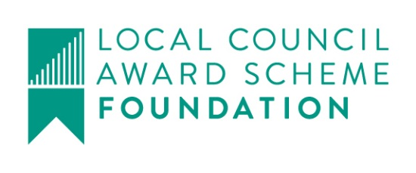

Great Maplestead Parish Council

Members of the Great Maplestead Parish Council you are hereby summonsed to attend a PARISH COUNCIL MEETING of Great Maplestead Parish Council at the Village Hall, Great Maplestead on Wednesday 23rd November 2016 at 7.30pm for the purpose of transacting the following business:
AGENDA

- Apologies and reasons for absence

- Minutes of previous meeting – Councillors are asked to agree the minutes of the Parish Council meeting held on the 16th October 2016 as a true and accurate account of proceedings of the meeting.

- Declarations of Interest (existence and nature) with regard to items on the agenda. Members of the Council are advised to declare the existence and nature of any ‘Disclosable Pecuniary’, ‘Other Pecuniary’ or ‘Non-Pecuniary’ interests relating to items on the agenda.

- County and District Matters – Updates and notifications to be received.

- Officers Reports & Information Exchange – No business decisions may be made.

- Public question time with respect to items on the agenda and other matters of mutual interest.
Note: When the Council starts to discuss any item on the agenda where a member has an interest, the member with that interest must have regard to the Code of Conduct and make the necessary disclosure and leave the meeting where appropriate. The maximum time allowed for public question time is 10 minutes or at the Chairman’s discretion. At the close of this item members of the public will no longer be able to address the Council except at the invitation of the Chairman; members with Disclosable or Other Pecuniary interests will not be allowed to speak or address the Council on those interests unless a dispensation has been approved.

- Progress Updates – Clerk to report on actions from the 16th October 2016 meeting.

8. Business Items
None tabled or carried forward

9. Financial Report
9.1 Current bank balances:-
Current account: | £ | 97.77 | Reserve account: | £ 3771.36

9.2 Noting of sums received:-
NWB Interest Paid Aug - Sep | .20p
BACS – BDC S106 Money for Car Park Extension | 6230.00
9.3 Ratification of payments made:-
Cheque – EALC – Council Training Session, Balance to Clear (original fee  £272.15 offset by £250 Training Award from 2013) | 22.15
Cheque – Information Commissioner – Annual Data Protection License  Cheque – Trustees of Great Maplestead Village Hall (hall hire Jun-Nov 2016)  Cheque – Mortimer Contracts Limited – Autumn Verge Cut  DD – E-ON Electricity Quarterly Street Lighting | 35.00  52.00  600.00  18.64
Payment(s) to be made requiring approval:-
None

9.4 Other Finance matters:-
Local Support Grant – Breakdown received from BDC detailing reduction in LSG over next 3 years, until it is finally withdrawn altogether.

Planning
10.1 Application Decisions
10.2.1 16/01307/FUL April Cottage, Monks Lodge Road. Proposed new access driveway to serve
High View. Granted 13/10/16
10.2.2 16/00270/TPO – Eastcote, Church Street. To carry out works on a tree affected by a TPO
6/88. Remove lower 4 branches and new growth at bottom of tree, reduce tree by 5
metres to the sides and 10 metres on top of tree. Granted 11.11.16

10.2 Applications Received
None

11. Correspondence – For notification
11.1 Essex County Council Highways, School Warning Wig-Wag Lights – Update
11.2 Braintree Council Street Cleaning – Street sweeping in Great Maplestead is scheduled for 14th December 2016, 20th March 2017, 23rd June 2017 & 25th September 2017.
11.3 BT Community Fibre Partnerships – Letter and information pack received from BT.
11.4 Parishioner Correspondence Regarding Bottle Banks

12. Content for E-newsletter

13. Items for the Next Agenda
Please note that no decisions can lawfully be made under this item, LGA 1972 section 12 10(2)(b) states that business must be specified, therefore the Council cannot lawfully raise matters for decision.

14. Date of next meeting: 11th January 2017 at 7.30pm
Ann Crisp – Clerk
e-mail: anncrisp@greatmaplesteadpc.co.uk
Tel: 01787 460216

