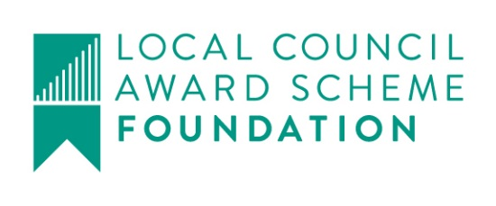

Great Maplestead Parish Council

Members of the Great Maplestead Parish Council you are hereby summonsed to attend a PARISH COUNCIL MEETING of Great Maplestead Parish Council at the Village Hall, Great Maplestead on Wednesday 29th March 2017 at 7.30pm for the purpose of transacting the following business:
AGENDA

- Apologies and reasons for absence

- Minutes of previous meeting – Councillors are asked to agree the minutes of the Parish Council meeting held on the 22nd February 2017 as a true and accurate account of proceedings of the meeting.

- Declarations of Interest (existence and nature) with regard to items on the agenda. Members of the Council are advised to declare the existence and nature of any ‘Disclosable Pecuniary’, ‘Other Pecuniary’ or ‘Non-Pecuniary’ interests relating to items on the agenda.

- County and District Matters – Updates and notifications to be received.

- Officers Reports & Information Exchange – No business decisions may be made.

- Public question time with respect to items on the agenda and other matters of mutual interest.
Note: When the Council starts to discuss any item on the agenda where a member has an interest, the member with that interest must have regard to the Code of Conduct and make the necessary disclosure and leave the meeting where appropriate. The maximum time allowed for public question time is 10 minutes or at the Chairman’s discretion. At the close of this item members of the public will no longer be able to address the Council except at the invitation of the Chairman; members with Disclosable or Other Pecuniary interests will not be allowed to speak or address the Council on those interests unless a dispensation has been approved.

- Progress Updates – Clerk to report on actions from the 22nd February 2017 meeting.

8. Business Items
8.1 Financial Regulations – To approve revised and updated Financial Regulations to allow provision for use of Internet Banking Facilities & Petty Cash arrangements. All transactions to be audited on a monthly basis (minimum) by the Chairman or Officer responsible for Financial Overview.
8.2 Internet Banking – To authorise NatWest Bank to accept instructions (whether by phone or electronic) of the Authorised User (Clerk) in respect of all matters relating to the operation of the Parish Council bank accounts by means of NatWest Digital Banking and Direct Banking.
8.3 BDC Community Governance Review, Initial Survey – To respond to initial survey questions regarding the future structure of local governance.

9. Financial Report
9.1 Current bank balances:-
Current account: | £49.91 |  | Reserve account: | £4157.52

9.2 Noting of sums received:-
NWB Interest Paid Feb 2017 | 3p
9.3 Ratification of payments made:-
None
Payment(s) to be made requiring approval:-
Cheque – Trustees of Great Maplestead Village Hall, Hall Hire Jan – Mar 2017 39.00
9.4 Other Finance matters:-
None

Planning
10.1 Application Decisions
None.
10.2 Applications Received
16/00655/FUL Land adjacent to 2 Toldish Cottages, Toldish Hall Road, Proposed detached dwelling with garage. Provisions regarding site planning splays.

11. Correspondence – For notification
Street Lighting Price Increase – Notification from A & J Lighting Solutions of Price increase to parts for 2017
Police & Crime Commissioner for Essex Public Consultation - a local case for change in the way police and fire and rescue services are governed. Closes 10th May 2017.
Electricity Price Increase – Notification from E-ON of price increase from 14.40p per kwh to 15.75p per kwh, with effect from 1st April 2017.

12. Content for E-newsletter

13. Items for the Next Agenda
Please note that no decisions can lawfully be made under this item, LGA 1972 section 12 10(2)(b) states that business must be specified, therefore the Council cannot lawfully raise matters for decision.

14. Date of next meeting: Parish Assembly 19th April 2017 at 7.30pm
Annual Meeting 24th May 2017 at 7.30pm
Ann Crisp – Clerk
e-mail: anncrisp@greatmaplesteadpc.co.uk
Tel: 01787 460216

