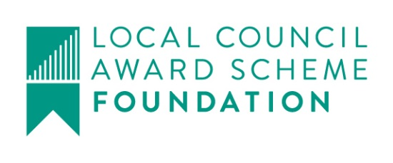

Great Maplestead Parish Council

Members of the Great Maplestead Parish Council you are hereby summonsed to attend a PARISH COUNCIL MEETING of Great Maplestead Parish Council at the Village Hall, Great Maplestead on Wednesday 10th January 2018 at 7.30pm for the purpose of transacting the following business:
AGENDA

- Apologies and reasons for absence

- Minutes of previous meeting – Councillors are asked to agree the minutes of the Parish Council meeting held on the 29th November 2017 as a true and accurate account of proceedings of the meeting.

- Declarations of Interest (existence and nature) with regard to items on the agenda. Members of the Council are advised to declare the existence and nature of any ‘Disclosable Pecuniary’, ‘Other Pecuniary’ or ‘Non-Pecuniary’ interests relating to items on the agenda.

- County and District Matters – Updates and notifications to be received.

- Officers Reports & Information Exchange – No business decisions may be made.

- Public question time with respect to items on the agenda and other matters of mutual interest.
Note: When the Council starts to discuss any item on the agenda where a member has an interest, the member with that interest must have regard to the Code of Conduct and make the necessary disclosure and leave the meeting where appropriate. The maximum time allowed for public question time is 10 minutes or at the Chairman’s discretion. At the close of this item members of the public will no longer be able to address the Council except at the invitation of the Chairman; members with Disclosable or Other Pecuniary interests will not be allowed to speak or address the Council on those interests unless a dispensation has been approved.

- Progress Updates – Clerk to report on actions from the 29th November 2017 meeting.

8. Business Items
Budget 2018/19 – To agree Parish Council budget for 2018/19.
Precept 2018/19 – To set and agree Parish Precept for 2018/19 in accordance with budget.

9. Financial Report
9.1 Current bank balances:-
Current account: |  | £7.23 | Reserve account: | £3217.40
9.2 Noting of sums received:-
NWB Interest Paid Nov - Dec 2017  BACS HMR&C VAT Reimbursement | 38p  £461.10
9.3 Ratification of payments made:-
SO Salary Qtrly Payment to Clerk, Mrs A Crisp Sep-Dec £1133.21
Transfers
From Reserve Account to Current Account £1550.00
From Reserve Account to Current Account £1100.00
Payment(s) to be made requiring approval:-
None
Planning
10.1 Application Decisions
None
10.2 Applications Received
17/02148/LBC St Giles Cottage, Lucking Street. Removal of rear lean-to part glazed, part corrugated cement based sheet roof covering and provision of natural grey slate and two conservation roof lights, red clay terracotta chimney pot and cowl and removal of plaster beneath existing opening.
17/02226/FUL Monks Haven, Gestingthorpe Road. Erection of single storey rear extension

11. Correspondence – For notification
Stansted Airport Correspondence – New flights to Dubai, to be operated by Emirates, will commence operation in June 2018.
Parishioner Correspondence – Letter received copying communication between parishioner and St Giles school regarding fallen branches. Further copy communication received from St Giles school. Matter to be resolved between affected parties.

12. Content for E-newsletter

13. Items for the Next Agenda
Please note that no decisions can lawfully be made under this item, LGA 1972 section 12 10(2)(b) states that business must be specified, therefore the Council cannot lawfully raise matters for decision.

14. Date of next meeting: 28th March 2018 at 7.30pm
Ann Crisp – Clerk
e-mail: anncrisp@greatmaplesteadpc.co.uk Tel: 01787 460216

