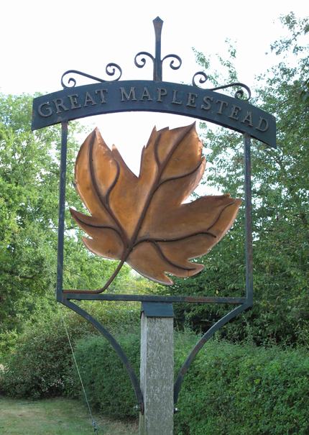


GREAT MAPLESTEAD PARISH COUNCIL
Members of the Great Maplestead Parish Council you are hereby summons to attend a PARISH COUNCIL MEETING of Gt. Maplestead Parish Council at the Village Hall, Gt. Maplestead on Wednesday 8th July 2015 at 7.30pm for the purpose of transacting the following business:

AGENDA

- Apologies and reasons for absence

- Minutes of previous meeting – Councillors are asked to agree the minutes of the Annual Parish Council meeting held on the 20th May 2015 as a true and accurate account of proceedings of the meetings.

- Declarations of Interest (existence and nature) with regard to items on the agenda.
Members of the Council are advised to declare the existence and nature of any ‘Disclosable Pecuniary’, ‘Other Pecuniary’ or ‘Non-Pecuniary’ interests relating to items on the agenda.

- County and District Matters – Updates and notifications to be received.

- Public question time with respect to items on the agenda and other matters of mutual interest. Note: When the Council starts to discuss any item on the agenda where a member has an interest, the member with that interest must have regard to the Code of Conduct and make the necessary disclosure and leave the meeting where appropriate. The maximum time allowed for public question time is 10 minutes or at the Chairman’s discretion. At the close of this item members of the public will no longer be able to address the Council except at the invitation of the Chairman; members with Disclosable or Other Pecuniary interests will not be allowed to speak or address the Council on those interests unless a dispensation has been approved.

- Progress Updates – Clerk to report on actions from the 20th May 2015 meeting.

7. Business Items
7.1. Review of Action List – Councillors to review and update.
7.1.1 Village Information Boards – Proposed new project from Grant Funding Working Party.
7.2 Parishioner Communication – Approval of flyer requesting parishioner e-mail addresses for future circulation of Parish Council newsletter and urgent updates.
7.3 ECC & Southend BC Joint Replacement Waste Local Plan Consultation – Consultation open 18th June – 20th July 2015. Council to decide on response.
7.4 EALC AGM 24th September – Council to consider and agree on any proposed motions to be raised at AGM.
7.5 Essex Air Ambulance Request to Consider Local Site for Recyled Clothing Bank – Council to agree response to request
7.6 Terms of Reference for Use of Village Playing Field – Terms and application requests to be approved.
7.7 Request for Village Poll on Need for Storage Container on Village Playing Field – Motion proposed by Councillor Elms.
  - Use of S106 Monies for purchase of replacement pole and new drainage on Village Playing Field -
Raised as agenda item at Annual Meeting 20th May 2015
  - Consider initiatives to reduce instances of unwanted dogs mess in public spaces – Raised as an
agenda item at Annual Meeting 20th May 2015
  - Proposed New Signage for Children’s Play Area, Prohibiting Dogs from Inside Play Area – Proposed
by Councillor Turner, following installation of new safety fencing.
  - Braintree Association of Local Councils – Letter inviting Parish Council membership
  - Parishioner Correspondence Regarding Safety Fencing at Village Playing Field – Dissatisfaction with
Appearance, response required.
  - Village Design Statement Brochures – Proposal to ensure a copy provided to new residents & copies
available at future Parish Council meetings.

8. Financial Report
8.1 Bank Reconciliation
8.2 Noting of payments received
8.3 Ratification of payments made & payments requiring approval
8.4 Other Financial Matters - Approval of new bank mandate signatories

9. Planning
9.1 Application Decisions
None
9.2 Applications Received
9.2.1 15/00600/LBC The Old Vicarage, Church Street. Removal of 2 internal walls in the attic (third floor)
9.2.2 15/00781/LBC St Giles Cottage, Lucking Street. Replacement windows, conservatory door & removal of corrugated sheet roof on rear lean to extension and provision of glazed roof & paiting of external walls.
9.2.3 15/00783/FUL Badgers, Lucking Street. External insulation & render applied over the ground floor brickwork.

10. Correspondence – For notification
10.1 BDC Local Plan Update – Newsletter as published on BDC website providing latest information on process.

11. Officers Reports & Information Exchange – No business decisions may be made.

12. Items for the Next Agenda
Please note that no decisions can lawfully be made under this item, LGA 1972 section 12 10(2)(b) states that business must be specified; therefore the Council cannot lawfully raise matters for decision.

13. Date of next meeting: 12th August 2015 at 7.30pm


Ann Crisp – Clerk acrisppc@btinternet.com
Tel: 01787- 460216

